Web Services SOAP Programs(Apache Axis 2):
SOAP Using Eclipse + Apache Axis2 :
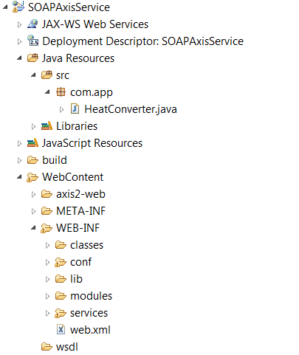
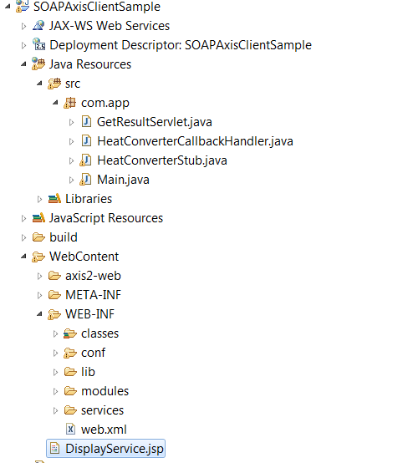
Service Code:
package com.app;
public class HeatConverter {

public double F2C(double forn){

return forn*32/100;
}
}
Web.xml(auto gerenated)
<?xml version="1.0" encoding="UTF-8"?>
<web-app xmlns:xsi="http://www.w3.org/2001/XMLSchema-instance" xmlns="http://java.sun.com/xml/ns/javaee" xmlns:web="http://java.sun.com/xml/ns/javaee/web-app_2_5.xsd" xsi:schemaLocation="http://java.sun.com/xml/ns/javaee http://java.sun.com/xml/ns/javaee/web-app_2_5.xsd" id="WebApp_ID" version="2.5">
<display-name>SOAPAxisService</display-name>
<servlet>
<display-name>Apache-Axis Servlet</display-name>
<servlet-name>AxisServlet</servlet-name>
<servlet-class>org.apache.axis2.transport.http.AxisServlet</servlet-class>
</servlet>
<servlet-mapping>
<servlet-name>AxisServlet</servlet-name>
<url-pattern>/servlet/AxisServlet</url-pattern>
</servlet-mapping>
<servlet-mapping>
<servlet-name>AxisServlet</servlet-name>
<url-pattern>*.jws</url-pattern>
</servlet-mapping>
<servlet-mapping>
<servlet-name>AxisServlet</servlet-name>
<url-pattern>/services/*</url-pattern>
</servlet-mapping>
<servlet>
<display-name>Apache-Axis Admin Servlet Web Admin</display-name>
<servlet-name>AxisAdminServlet</servlet-name>
<servlet-class>org.apache.axis2.transport.http.AxisAdminServlet</servlet-class>
<load-on-startup>100</load-on-startup>
</servlet>
<servlet-mapping>
<servlet-name>AxisAdminServlet</servlet-name>
<url-pattern>/axis2-admin/*</url-pattern>
</servlet-mapping>
</web-app>
Test At Client Level:
package com.app;

import com.app.HeatConverterStub.F2C;
import com.app.HeatConverterStub.F2CResponse;

public class Main {

public static void main(String[] args) throws Exception {
HeatConverterStub stub=new HeatConverterStub();
F2C obj=new F2C();
obj.setForn(1505.23);
F2CResponse res=stub.f2C(obj);
System.out.println(res.get_return());

}

}
Display.jsp
<%@ page language="java" contentType="text/html; charset=ISO-8859-1"
pageEncoding="ISO-8859-1"%>
<!DOCTYPE html PUBLIC "-//W3C//DTD HTML 4.01 Transitional//EN" "http://www.w3.org/TR/html4/loose.dtd">
<html>
<head>
<meta http-equiv="Content-Type" content="text/html; charset=ISO-8859-1">
<title>Insert title here</title>
</head>
<body>
<form action="getResult">
<pre>
Enter value : <input type="text" name="data"/>
<input type="submit" value="Calculate"/>
</pre>
</form>
<%if((request.getAttribute("res"))!=null){
out.print(request.getAttribute("res"));
} %>
</body>
</html>
Servlet Program:
package com.app;

import java.io.IOException;
import javax.servlet.ServletException;
import javax.servlet.http.HttpServlet;
import javax.servlet.http.HttpServletRequest;
import javax.servlet.http.HttpServletResponse;

import com.app.HeatConverterStub.F2C;
import com.app.HeatConverterStub.F2CResponse;

/**
* Servlet implementation class GetResultServlet
*/
public class GetResultServlet extends HttpServlet {
private static final long serialVersionUID = 1L;

/**
* @see HttpServlet#HttpServlet()
*/
public GetResultServlet() {
super();
// TODO Auto-generated constructor stub
}

/**
* @see HttpServlet#doGet(HttpServletRequest request, HttpServletResponse response)
*/
protected void doGet(HttpServletRequest request, HttpServletResponse response) throws ServletException, IOException {
String data=request.getParameter("data");
double data1=Double.parseDouble(data);
HeatConverterStub stub=new HeatConverterStub();
F2C obj=new F2C();
obj.setForn(data1);
F2CResponse res=stub.f2C(obj);
request.setAttribute("res", res.get_return());
request.getRequestDispatcher("DisplayService.jsp").forward(request, response);
}

}

